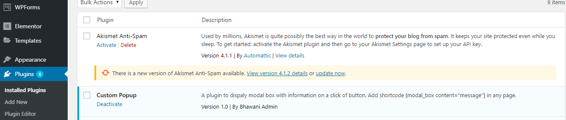

*First of all, need to install the plugin and it will appear on plugins then activate the plugin.

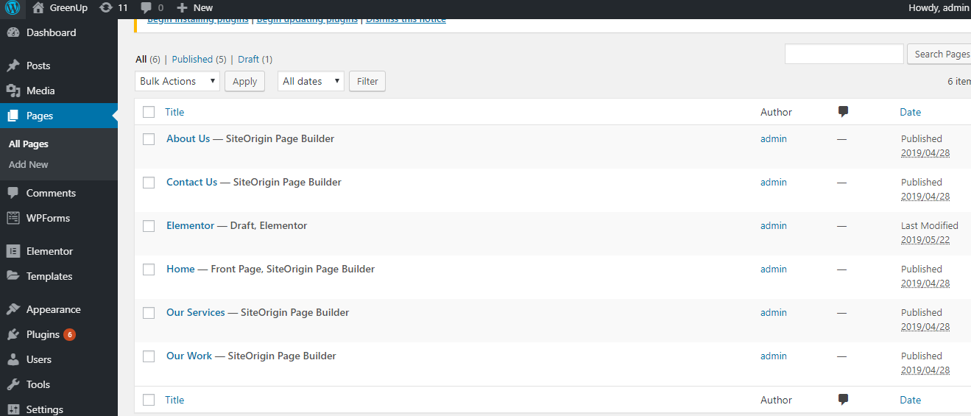

*Then go to pages and pick one page.

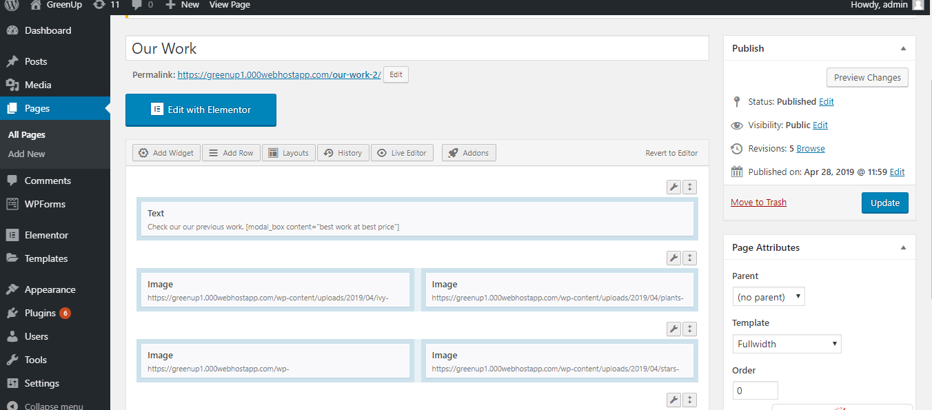

*In my case, I choose our work.

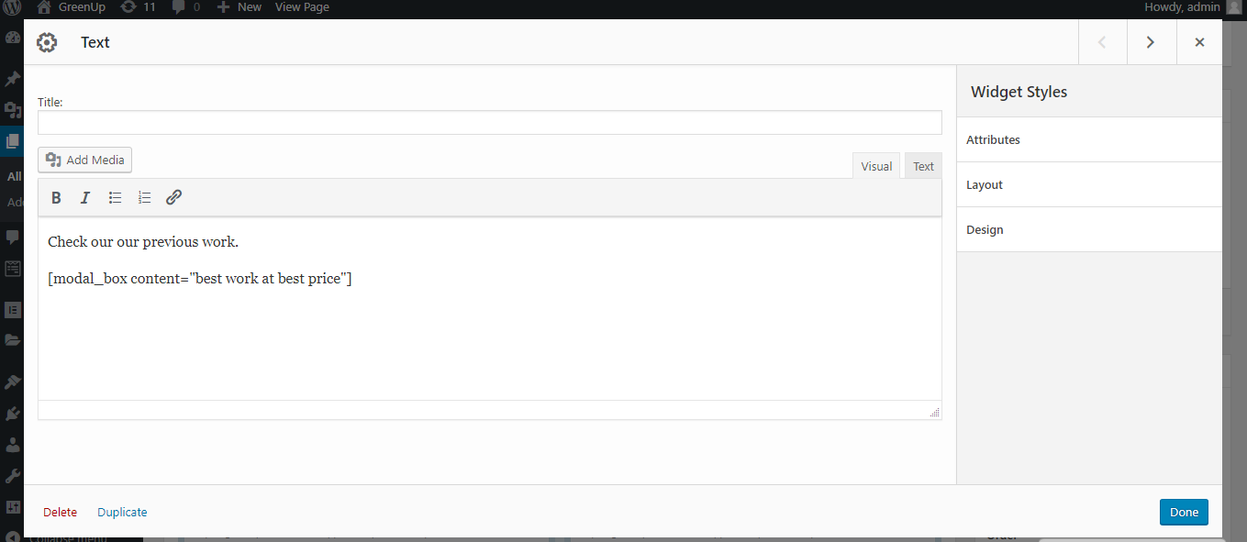

*And insert a code under text **[modal_box content="best work at best price"]**

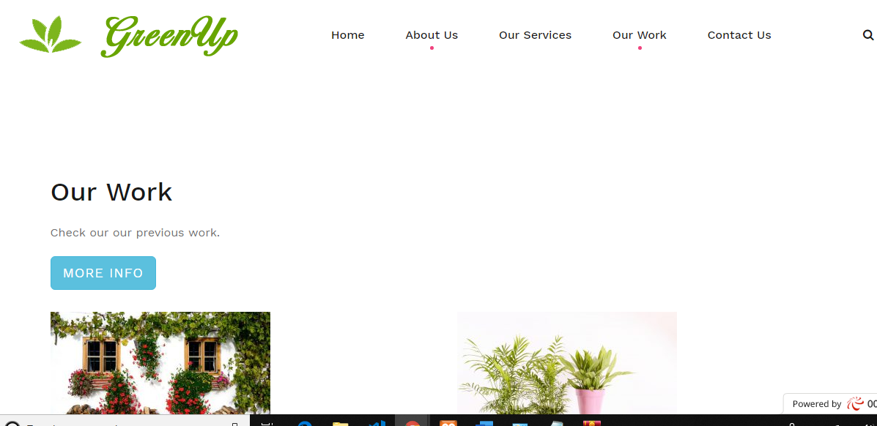

*Now just need to click on the more info

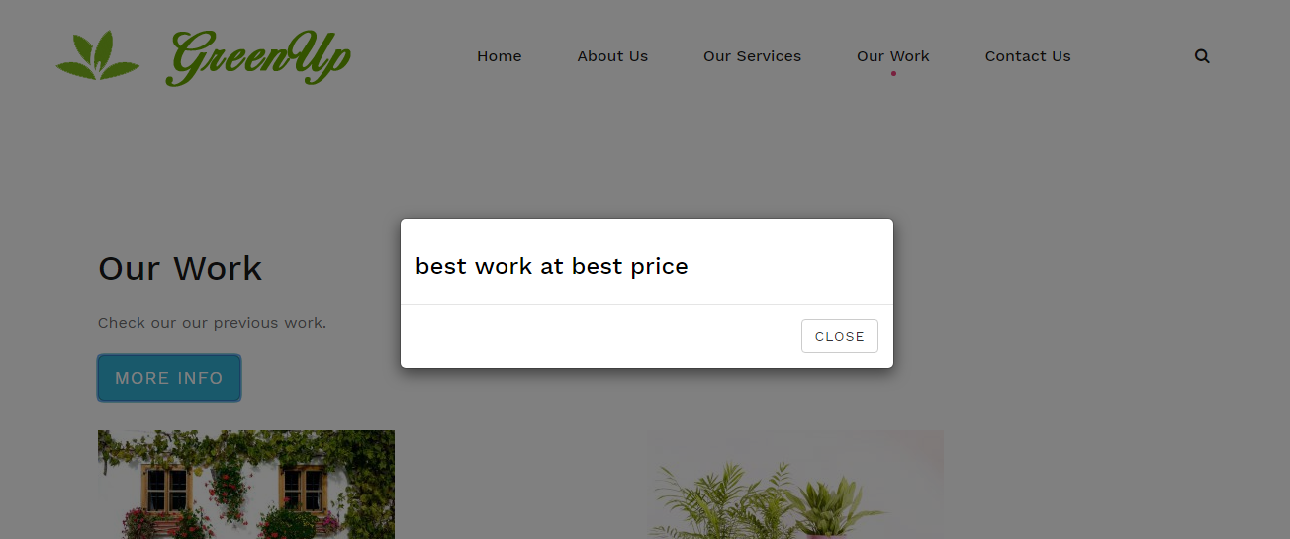

* Message will appear on the screen.